**PART-B**

**2. Create a web page containing simple calculator which should have basic arithmetic (+,-,*,/ ) operation on two floating point numbers and show result. Validations to be followed:**

**• . (Decimal point) should be taken only once for an operand.**

**• Operand can be negative.**

**• Division by zero must be shown proper error message in result.**

**Sample screen shot:**

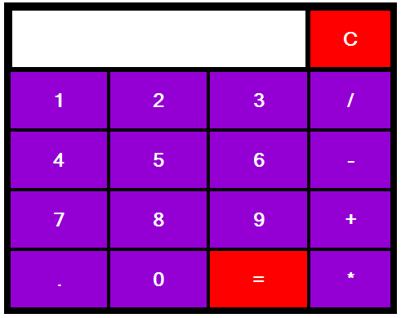

**HTML CODE:**

<!DOCTYPE html>

<head>

<title>Simple Calculator</title>

<style>

table{

border:5px solid black;

margin-left:auto;

margin-right:auto;

background-color:black;

}

input[type="button"]{

width:100%;

padding:20px 40px;

background-color:darkviolet;

color:white;

font-size:24px;

font-weight:bold;

border:none;

border-radius:5px;

}

input[type="text"]{

padding:20px 40px;

font-size:24px;

font-weight:bold;

border:none;

border-radius:5px;

background-color:white;

border:2px solid black;

}

</style>

</head>

<body>

<table class="Calculator">

<tr>

<td colspan="3"><input class="display-box" type="text" id="result" disabled/></td>

<!--clearScreen() function clears all the values-->

<td><input type="button" value="C" onclick="clearScreen()" id="btn" style=background-color:red;/></td>

</tr>

<tr>

<!-- diplay() function dispalys the value of clicked button-->

<td><input type="button" value="1" onclick="display('1')"/></td>

<td><input type="button" value="2" onclick="display('2')"/></td>

<td><input type="button" value="3" onclick="display('3')"/></td>

<td><input type="button" value="/" onclick="display('/')"/></td>

</tr>

<tr>

<td><input type="button" value="4" onclick="display('4')"/></td>

<td><input type="button" value="5" onclick="display('5')"/></td>

<td><input type="button" value="6" onclick="display('6')"/></td>

<td><input type="button" value="-" onclick="display('-')"/></td>

</tr>

<tr>

<td><input type="button" value="7" onclick="display('7')"/></td>

<td><input type="button" value="8" onclick="display('8')"/></td>

<td><input type="button" value="9" onclick="display('9')"/></td>

<td><input type="button" value="+" onclick="display('+')"/></td>

</tr>

<tr>

<td><input type="button" value="." onclick="display('.')"/></td>

<td><input type="button" value="0" onclick="display('0')"/></td>

<!-- calculate() function evaluates the mathematical expression-->

<td><input type="button" value="=" onclick="Calculate()" id="btn" style=background-color:red;/></td>

<td><input type="button" value="*" onclick="display('*')"/></td>

</tr>

</table>

<script>

function clearScreen(){

document.getElementById("result").value=" ";

}

function display(value){

document.getElementById("result").value+=value;

}

function Calculate(){

var p=document.getElementById("result").value;

var q=eval(p);

document.getElementById("result").value=q;

}

</script>

</body>

</html>